Getting Started v1.0

Install git on your machine
https://www.linode.com/docs/development/version-control/how-to-install-git-on-linux-mac-and-windows/

Once installed, verify the version by running git --version
You should get something like git version 2.21.0 as a response

Visit azure devops URL and login (using the invitation sent from us)
Once logged in, navigate to the phonevice repo as shown below
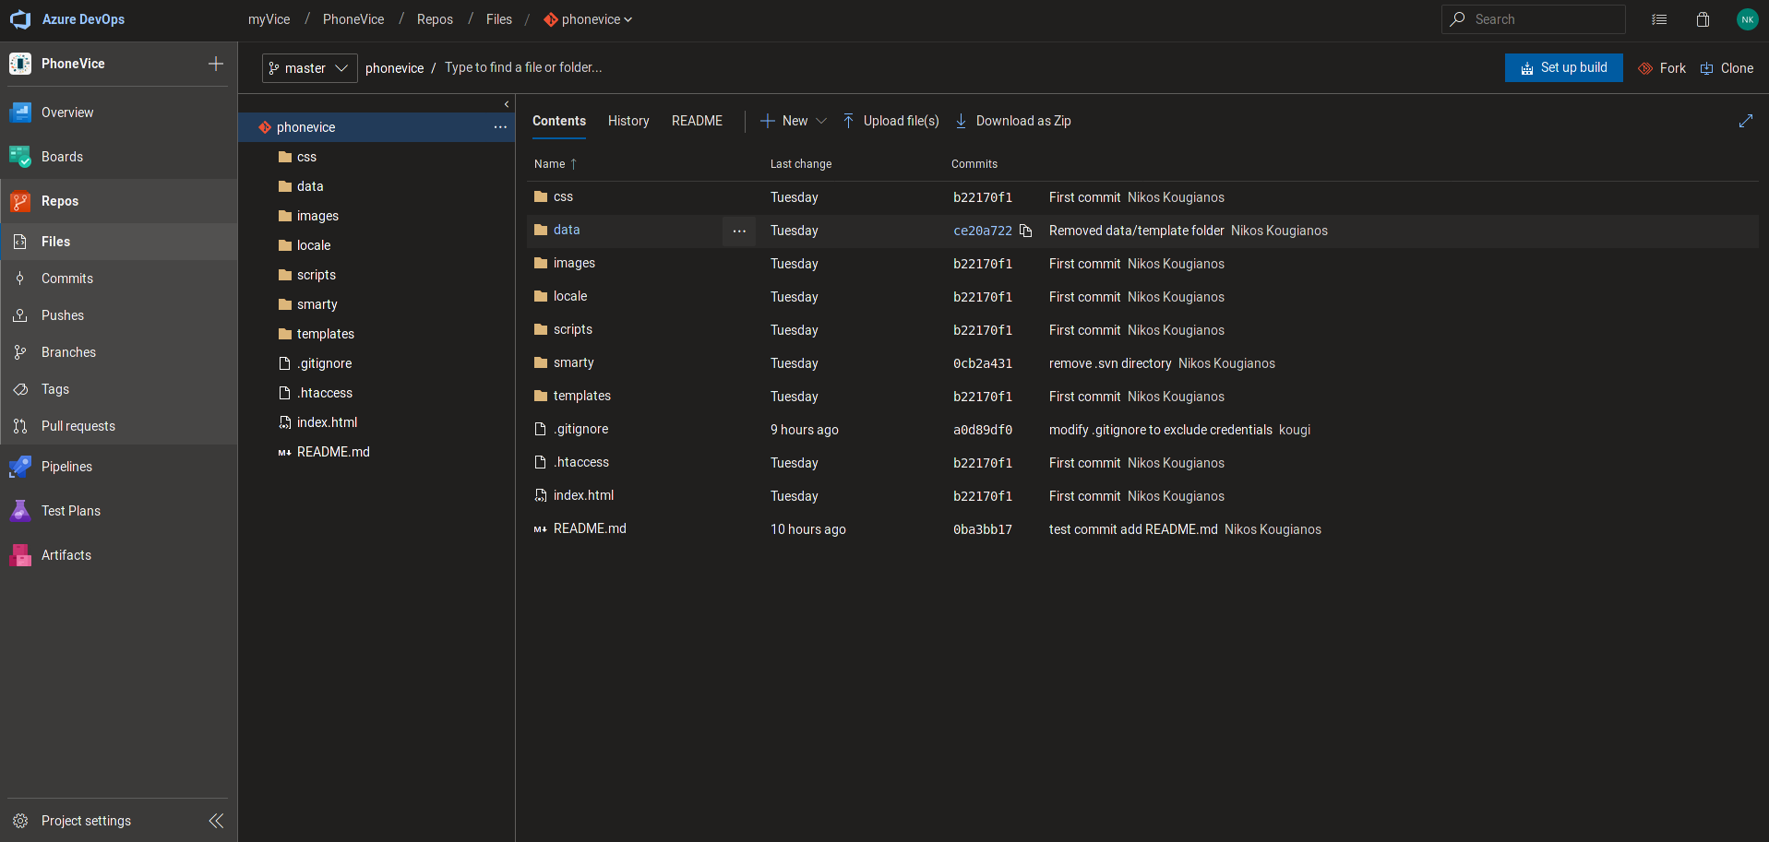

Click on Clone on the upper right corner, then click on Generate Git credentials

You should see something like this
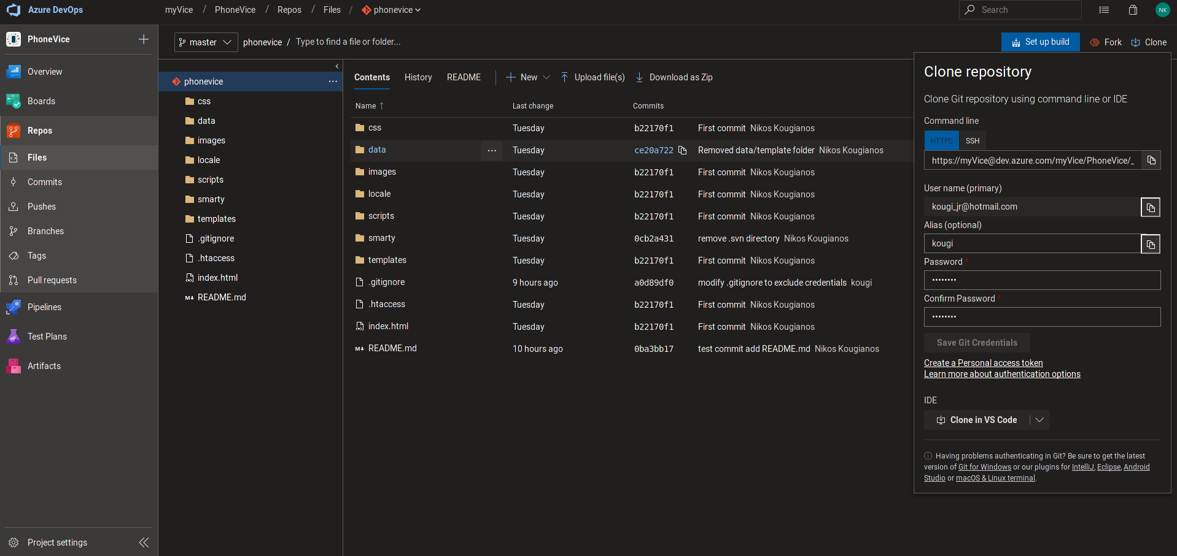

Create an alias that you will be using for the commits
(For example if you see the .gitignore file you will notice kougi in the right which is my alias)

Create a unique password

Once you have done all that, you are ready to git clone the project locally on your machine.

Use the command

git clone https://kougi@dev.azure.com/myVice/PhoneVice/_git/phonevice

where kougi will be your own alias

After that you can insert your credentials, and if all go as planned you will have a local copy ready to play on your PC

Once you have cloned the repo, you should be able to test it locally, assuming that you have PHP and Apache property installed and configured on your machine

*In case you get a 500 HTTP Internal Server Error, then probably something is wrong with the permissions on the smarty folder. The project is configured to run on centOS/fedora operating systems, so for Debian/Ubuntu some tweaking might be needed.

If that is not the case then you will need to install PHP and Apache on your machine.

Windows
https://www.sitepoint.com/how-to-install-apache-on-windows/
https://www.sitepoint.com/how-to-install-php-on-windows/

Ubuntu
https://www.linode.com/docs/web-servers/lamp/install-lamp-stack-on-ubuntu-16-04/

To sum up, your first task is to successfully git clone the project and be able to test it on your local apache server. Once you have done that please reply to the corresponding thread on Slack so that we can discuss further tasks.

Feel free to ask any questions for troubleshooting/help.

